Guoxin Li
STA 138 –Final Project

INTRODUCTION
In my second project for this class, I used multiple logistic regression model to classify iris species. In order to keep our analysis simple, we didn’t cover all the species, only focused on specifying Iris virginica and Iris versicolor. This model limits us only can solve binary classification problem. But in the Iris data, it has three different species. In paper, I use multinomial logistic regression as a classification method for a response variable that has more than two classes.

MATERIAL
Iris is a multivariate data set introduced by Ronald Fisher in his 1936 paper, The Use of Multiple Measurements in Taxonomic Problems. Although it was originally presented as an example of linear discriminant analysis, it is also famous in data mining. It contains three different species of the Iris（Iris setosa, Iris versicolor and Iris virginica), each with fifty samples and four characteristics: sepal length, sepal width, petal length, and petal width (all numerical and measured in centimeters). Since the Iris flower data is built in R, we used the data directly from R.

METHODS
In the final project assignment, it asks us to perform a multiple logistic regression, so instead just apply multiple logistic regression, since I have three category for my response variable, so I decide to use multinomial regression. In statistics, multinomial logistic regression is a classification method that generalizes logistic regression to multiclass problems, i.e. with more than two possible discrete outcomes. That is, it is a model that is used to predict the probabilities of the different possible outcomes of a categorically distributed dependent variable, given a set of independent variables. In this case, Iris setosa (k = 1), Iris virginica (k = 2), and Iris versicolor (k = 3), are three categories in this data. Our objective is to determine a probability function which takes in an input Iris (sepal length, sepal width, petal length, petal width), returns ‘the probability of this Iris to be three different species’ and do the classification.

RESULTS
4.1
For multiple logistic regression, the model is:

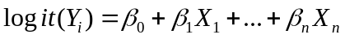

But since I have more than two classes in my response variable, so the model on above can’t apply to the data. The most appropriate model to apply is multinomial linear regression and the model is:

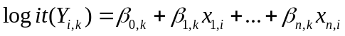

Where k is from 1 to K represents the category, i is from 1 to I represents the i^{th} observation.

One fairly simple way to arrive at the multinomial logit model is to imagine, for K possible outcomes, running K-1 independent binary logistic regression models, in which one outcome is chosen as a "pivot" and then the other K-1 outcomes are separately regressed against the pivot outcome. This would proceed as follows, if outcome K (the last outcome) is chosen as the pivot:

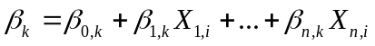

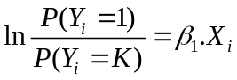
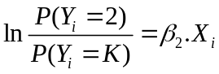
…..
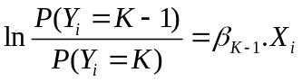

It will help to understand the output of parameters from R.

4.2
First I did a forward model selection by using AIC as the criteria. Table 1 shows the AIC result for the four different models
Model AIC
fit1(Petal.Width) 41.4208
fit2(Petal.Width+Petal.Length) 32.56351
fit3(Petal.Width+Petal.Length+Sepal.Length) 31.4924
fit4(Petal.Width+Petal.Length+Sepal.Length+Sepal.Width) 31.89855
Table 1 AIC for the models

From the table 1, we can see that model 3 gives us the smallest AIC, so I chose model 3 as the best model. Table 1 shows the estimate coefficients with standard error and Z test for model3.

Coefficients:
Estimate Std. Error z value Pr(>|z|)
(Intercept):1 31.447 41652.088 0.001 0.9994
(Intercept):2 40.831 18.548 2.201 0.0277 *
Petal.Width:1 -30.808 9784.486 -0.003 0.9975
Petal.Width:2 -10.102 4.606 -2.193 0.0283 *
Petal.Length:1 -28.862 5619.418 -0.005 0.9959
Petal.Length:2 -9.754 4.465 -2.185 0.0289 *
Sepal.Length:1 17.889 9737.517 0.002 0.9985
Sepal.Length:2 3.839 2.130 1.802 0.0715 .
Table 2 model coefficients
This is a nominal model for the response category relative risks, with separate slopes on all three predictors. The (intercept) 1 and (intercept) 2 are intercept terms for the log odds of the first two response categories, setosa and versicolor versus the reference category, virginica. The last eight parameter are the slopes for the models for the first two categories. Vglm accepts the third category as the reference category.
The models for the log odds of an iris flower being a setosa versus a virginica, and the relative risk of an iris flower being a versicolor species versus a virginica species are respectively
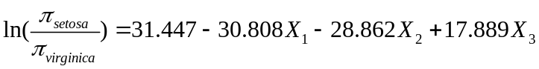
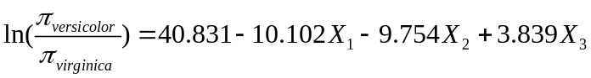

The coefficients express the effects of the predictor variables on the log odds of being in one category versus the reference category.
For example, the estimated coefficient 3.839 indicates that the probability of being species 2 (versicolor) compared to the probability of being species 3 (virginica) (the relative risk of being a versicolor versus a virginica) increases exp(2.465) times for each unit increase in X₃, the first measurement, given all else equal.
In terms of log odds, you can say that the relative odds of being a versicolor versus a virginica increases exp(2.465) times with a one-unit increase in X₃ given all else is equal.

4.3
The respective P-values of the all parameters for class 1 is not significant. For the class 2, all the parameters are significant at the 0.1 level of significance. I will explain this in the discuss section.
The 95% Wald confidence intervals agree with the above conclusions:
2.5 % 97.5 %
(Intercept):1 -8.160515e+04 81668.038508
(Intercept):2 4.477316e+00 77.184752
Petal.Width:1 -1.920805e+04 19146.431411
Petal.Width:2 -1.912936e+01 -1.073750
Petal.Length:1 -1.104272e+04 10984.994178
Petal.Length:2 -1.850594e+01 -1.002812
Sepal.Length:1 -1.906729e+04 19103.071528
Sepal.Length:2 -3.357343e-01 8.013052
Table 3 95% Wald confidence intervial

The 95% Wald confidence interval for the odds ratio for Petal.Width2 is given by (-19.23, -1.074) fixed other variables. This means when the Petal.Width increasing additional centimeter, we are 95% confident the odds of the Iris versicolor will increase by as little as 4.451e-7% to as much as 34.2%. The 95% Wald confidence interval for the odds ratio for Petal.Length2 is given by (-18.505, -1.0028) fixed all other variables. This means when Petal.Length increasing additional point, we are 95% confident the odds of the Iris versicolor will increase by as little as 9.191e-7% to as much as 36.69%.
From the odds results, it raises a problem that the value for odds itself is very small, and the confidence interval for the odds even smaller than that. For this problem, our exploratory variables have correlation between each other. I plot the correlation for each exploratory variables, it shows in figure 1.
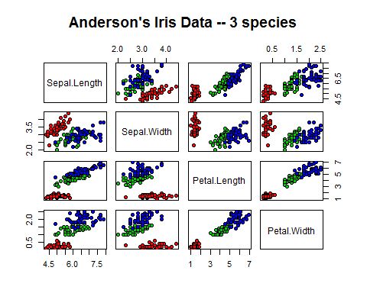
Figure 1 Linear discriminant analysis

In figure 1, red represents setosa, green represents versicolor and blue represents virginica. It shows Sepal.Length are correlated with Petal.Length and Petal.Width, Petal.Length correlated with Petal.width. It also shows that setosa can be easily separate by any variables. So there is multicollinearity between the exploratory variables, it causes the estimated odds ratio strange and the confidence interval extremely large.

Statistics:
X^2 df P(> X^2)
Likelihood Ratio 1.273719 51 1
Pearson 1.283276 51 1

Table 4 Pearson and Likelihood Ratio test
The Chi-Square test statistic was 1.283 (df = 51) with a p-value of around to 1, the likelihood ratio test was 1.274 (df = 51) with a p-value of around to 1. Therefore at α = 05. we can not reject the null hypothesis that the model is fitting the data.

DISCUSSION
5.1
Linear regression can be a fast and powerful tool to model complex phenomena. However, it makes several assumptions about your data, and quickly breaks down when these assumptions (e.g. a linear relationship exists between the predictors and the dependent variable) break down. In this part, we will do some diagnostics and residual analysis to ensure that our regression does not violate basic assumptions. We will also identify outliers and assess how well our model fits the data.
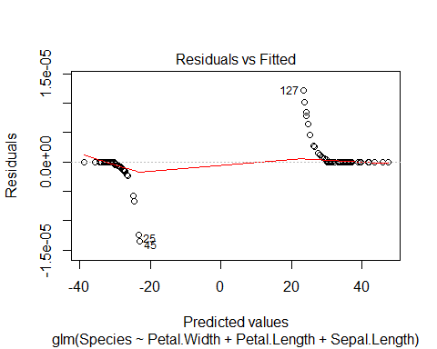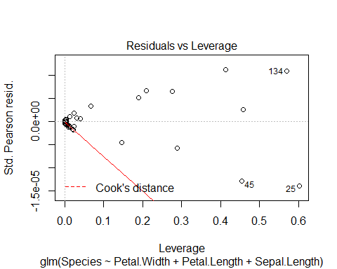

Figure 2 plots of regression diagnostics for setosa/ versicolor
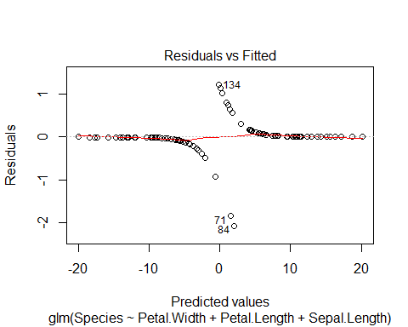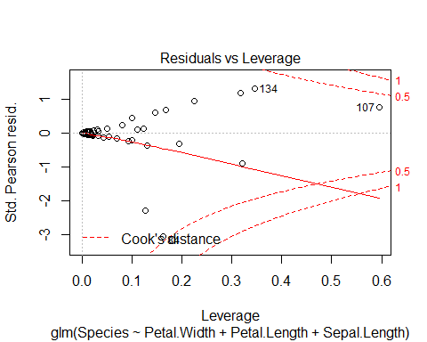
Figure 3 plots of regression diagnostics for virginica / versicolor

The left plot shows the residuals versus the fitted values in both figure 1 and figure 2. If there was no scatter, all the points would fall exactly on the red horizontal line, but here, the points are split in two lines. Because Width and Length have a strong positive effect, small width values for an observation of y = 1 must have a relatively large positive residual, whereas for large width values for an observation of y = 0 will have a relatively large negative residual. When plotted against fitted values, a plot of the raw residuals consists merely of two lines of points which diverge to parallel. Both plots in figure 1 and figure 2 show this pattern.

The lower right plot shows the standardized residuals against leverage. The standardized residuals are symmetrically centered around zero and reach 2-3 standard deviations away from zero, as would be expected for a normal distribution. Leverage is a measure of how much each data point influences the regression. Here, we can see that R automatically marked the outliers, we see that in figure 1, the 25th, 45th and 134th observations might have problem, in figure 2, the 84th, 107th and 134th observations might have problem.

5.2
To continue our analysis, we calculated four different types of residuals: the Pearson residual, standardized Pearson residual, deviance residual, and the standardized deviance residual. In this section we won’t list all of the residuals, because we have 150 observations (see full data in the Appendix), but we will include the values for the 84th, 107th and 134th observation, since they are unusually large:

84 107 134
Pearson -2.7826511 0.4899599 1.0591560
Deviance -2.0824362 0.6559883 1.2265971
Std.Deviance -2.277058 1.030935 1.517877
Std.Pearson 3.0427136 0.7700087 1.3106736

Table 5 Residuals

From Pearson, std.Pearson, and std.deviance residuals, we conclude that our model doesn’t fit this particular observation very well. In fact, these values confirm the analysis from the Figure 2 plot of standardized residuals against leverage, which led us to believe that the 84th observation is an outlier.

5.3
By calculating a confusion matrix to show how well our model performs:
Logit predictions from project 2
versicolor virginica
versicolor 47 3
virginica 3 47
Table 6 Confusion matrix from project 2

Multinomial logit predictions
setosa versicolor virginica
setosa 50 0 0
versicolor 0 48 1
virginica 0 2 49
Table 7 Confusion matrix of multinomial logistic regression
We found that only two points are misclassified in versicolor, one points is misclassified in virginica, and no point is misclassified in setosa. Comparing to what I got from project 2, I get one more correct on versicolor classification, and two more correct on virginica classification.
The confusion matrix shows that using multinomial logistic regression, it not only successful does a prediction on three different classes, also improves classification accuracy, we are confident that the model is appropriate.

CONCLUSION AND DISCUSSION
This paper proposes multinomial logistic regression model to classify iris species because this method is good for solving multiple class response variable classification problems. The effect of Petal.Width, Petal.Length and Sepal.Length were found to be significant. The model’s fit was analyzed by examining association of predicted and observed probabilities of success, and by using the Chi-square and likelihood goodness of fit test. Based on these results, we can not reject the hypothesis that the model is fitting the data; yet, we would be more comfortable with a model that provides more support of fit. In future work, it might be possible to improve classification accuracy by using non-linear classifier.

